# **Name: Abdurrahman Qureshi**

# **Roll No: 242466**

Practical No: 1

Date Of Performance: 08/07/2025

Aim: To understand and demonstrate the creation, connection, and basic usage of a Windows EC2 instance in AWS, followed by proper termination.

1. What is DevOps?
2. What are AWS EC2? Why EC2
3. Launch one instance of AWS EC2. This instance should be Windows [ Free Tier Available]. Get connected to instances using RDP. Explain each step of EC2 creation and launching with the help of screenshots.

Open google.com from the instances, search your instance IP address.

[Terminate the instances after performing the practical]

Ans 1:

DevOps is a combination of **Development (Dev)** and **Operations (Ops)**, representing a **culture, set of practices, and tools** that improve collaboration between software development (Dev) and IT operations (Ops) teams. The goal is to **automate and streamline** the software delivery process, ensuring **faster, more reliable, and scalable** deployments.

**Key Aspects of DevOps:**

**- Automation** – Automating repetitive tasks (CI/CD pipelines, infrastructure as code).  
**- Continuous Integration & Continuous Deployment (CI/CD)** – Frequent code integration and automated deployments.  
**- Infrastructure as Code (IaC)** – Managing infrastructure using code (e.g., Terraform, AWS CloudFormation).  
**- Monitoring & Logging** – Tracking application performance (e.g., Prometheus, AWS CloudWatch).  
**- Collaboration** – Breaking silos between Dev and Ops teams.

- Popular DevOps tools: **Docker, Kubernetes, Jenkins, Ansible, Terraform, AWS, Azure DevOps, GitLab CI/CD**.

Ans 2:

Amazon Elastic Compute Cloud (EC2) is a scalable cloud computing service provided by AWS that allows users to rent virtual servers (instances) in the cloud. It provides resizable compute capacity, eliminating the need for physical hardware.

Why Use EC2?

- Scalability – Easily scale up/down based on demand (Auto Scaling).

- Cost-Effective – Pay only for what you use (On-Demand, Spot, Reserved Instances).

- Flexibility – Choose OS (Linux, Windows), instance types (CPU, GPU, RAM optimized), and configurations.

- Security – Secure with VPC, IAM roles, security groups, and encryption.

- Integration – Works seamlessly with other AWS services (S3, RDS, Lambda, etc.).

- Reliability – Highly available with multiple Availability Zones (AZs).

Common Use Cases:

- Hosting websites & web apps

- Running backend services

- Big data processing

- Machine learning & AI workloads

- Game Servers

Ans 3:

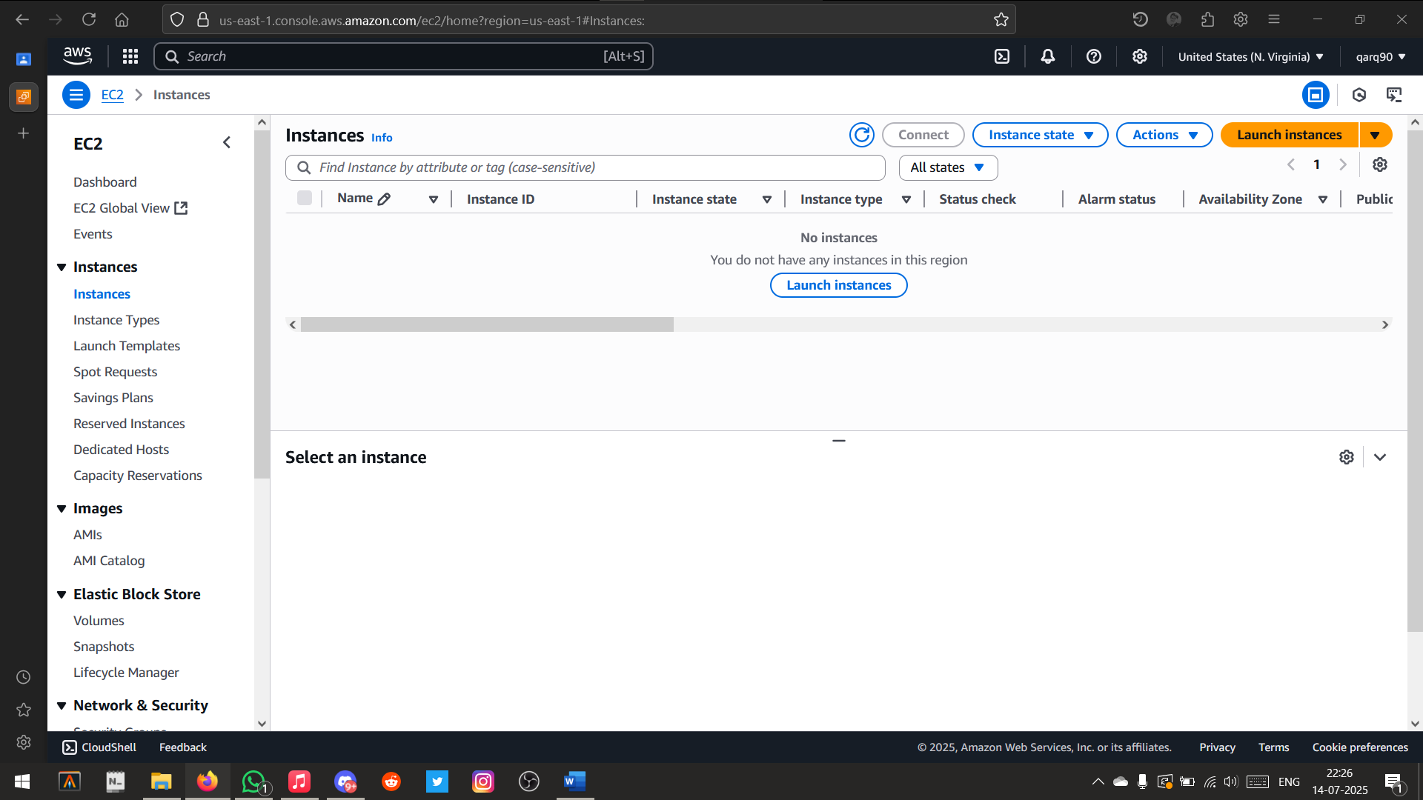

Launching/Creating and EC2 Instance

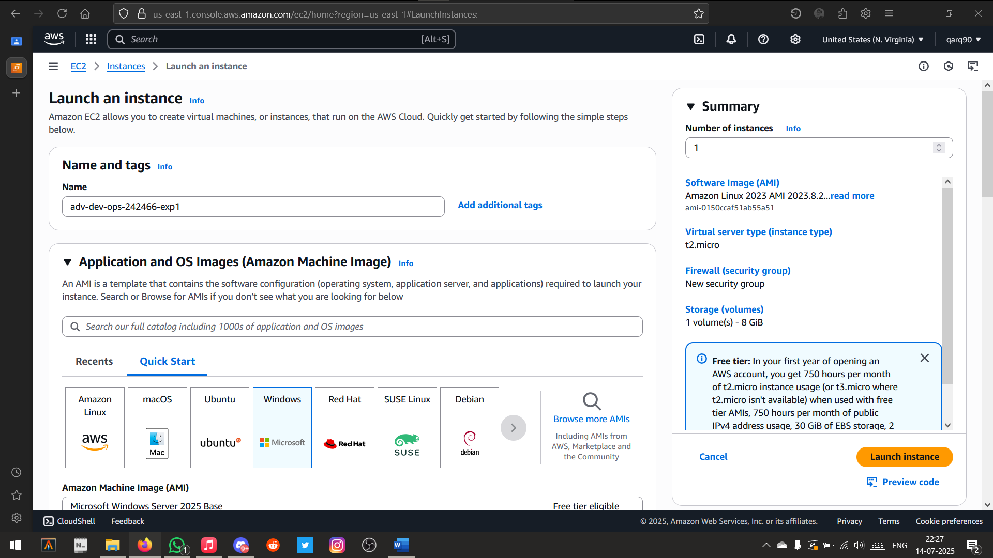

Setting name and Operating System of the EC2 Instance

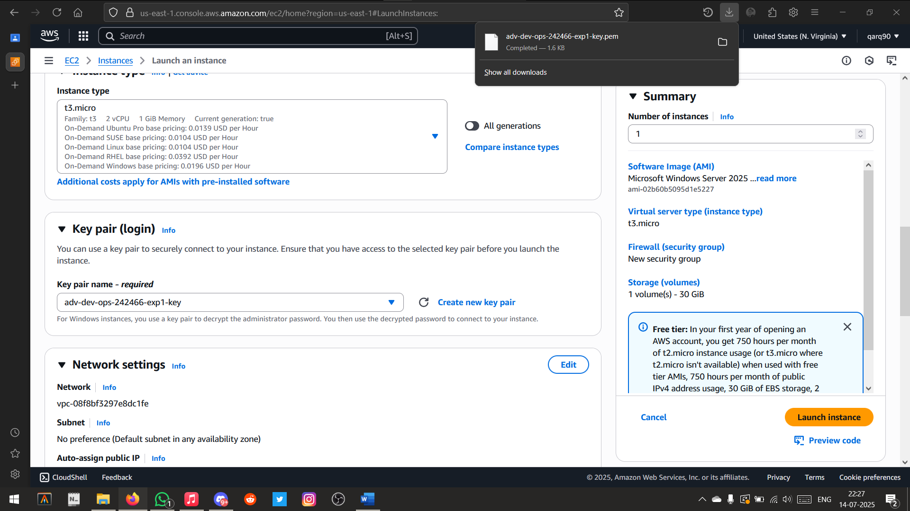

Created and Downloaded the Key pair .pem file

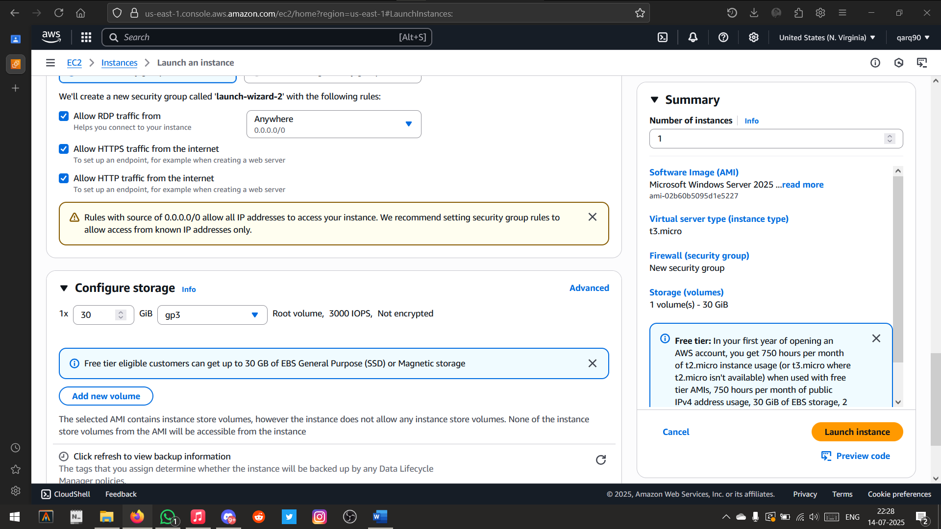

Setting up the network settings

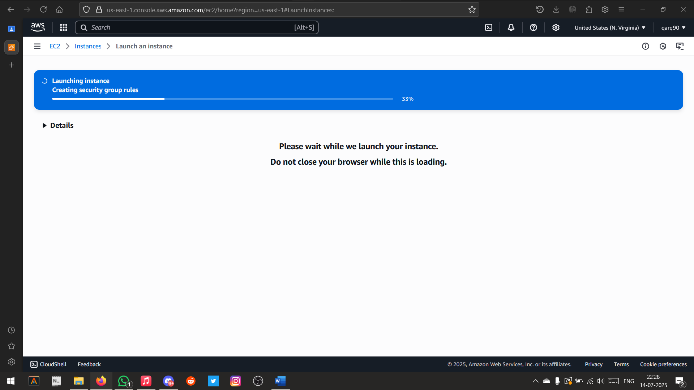

Instance Creating

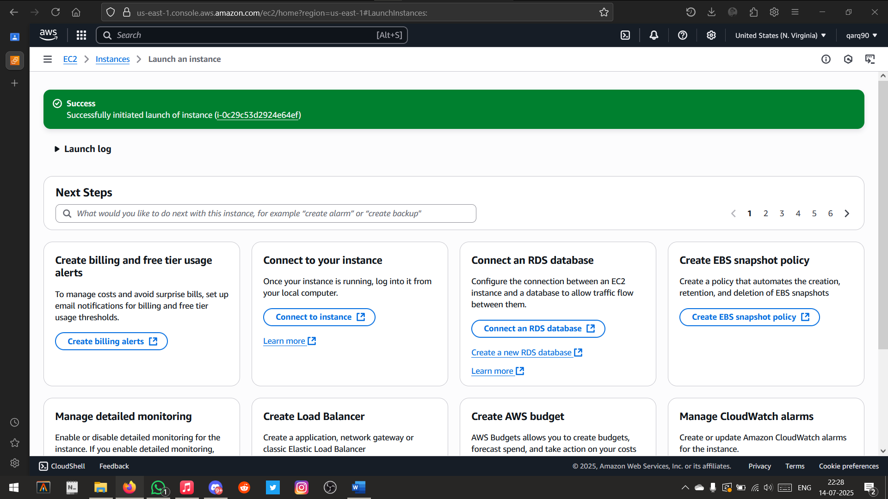

Instance Created Successfully

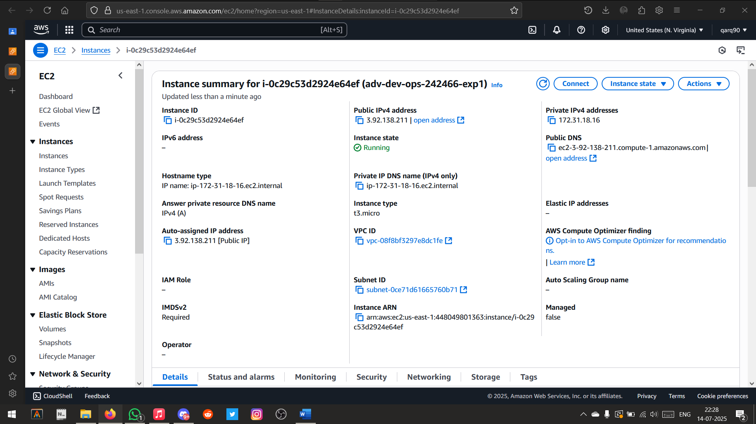

Instance Details

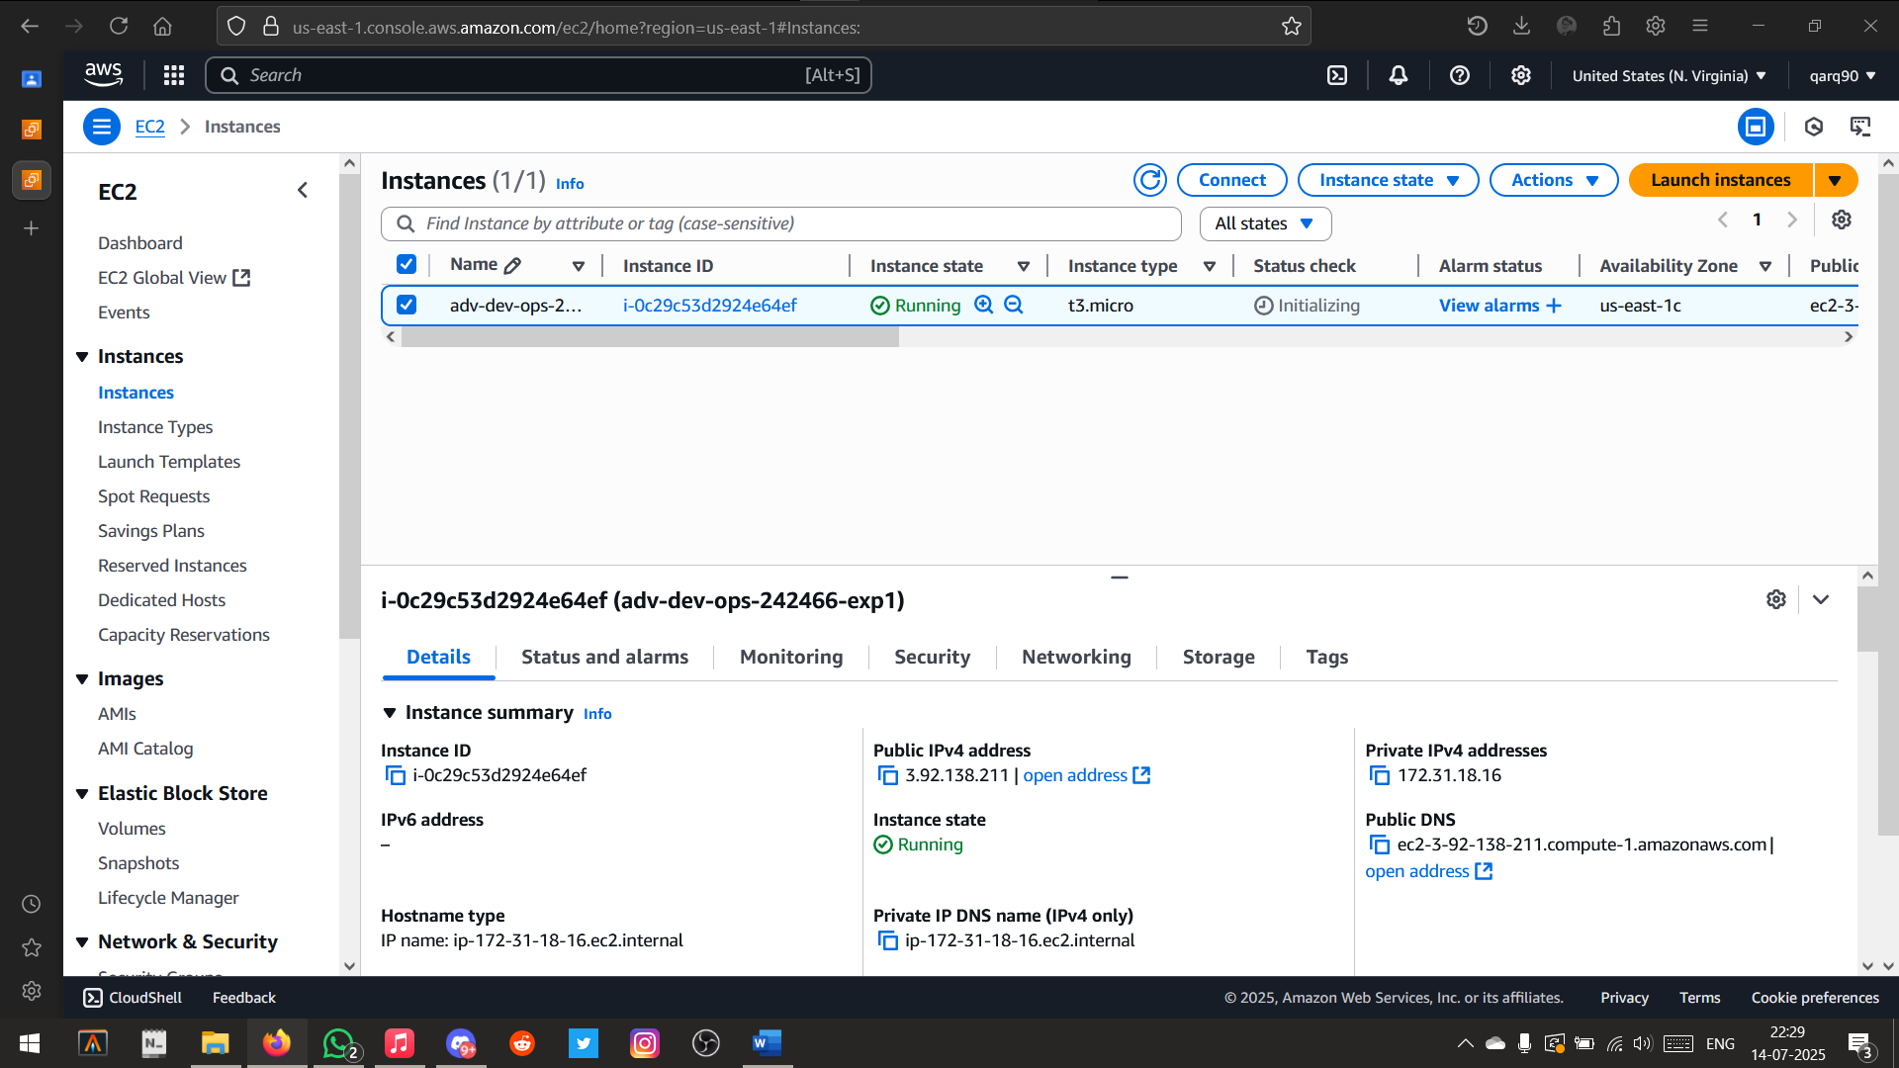

Current State of the Instance

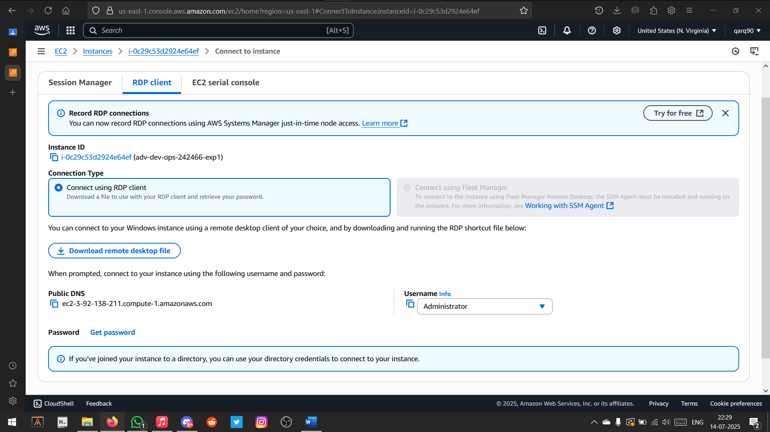

Using RDP Client to connect to the EC2 Instance

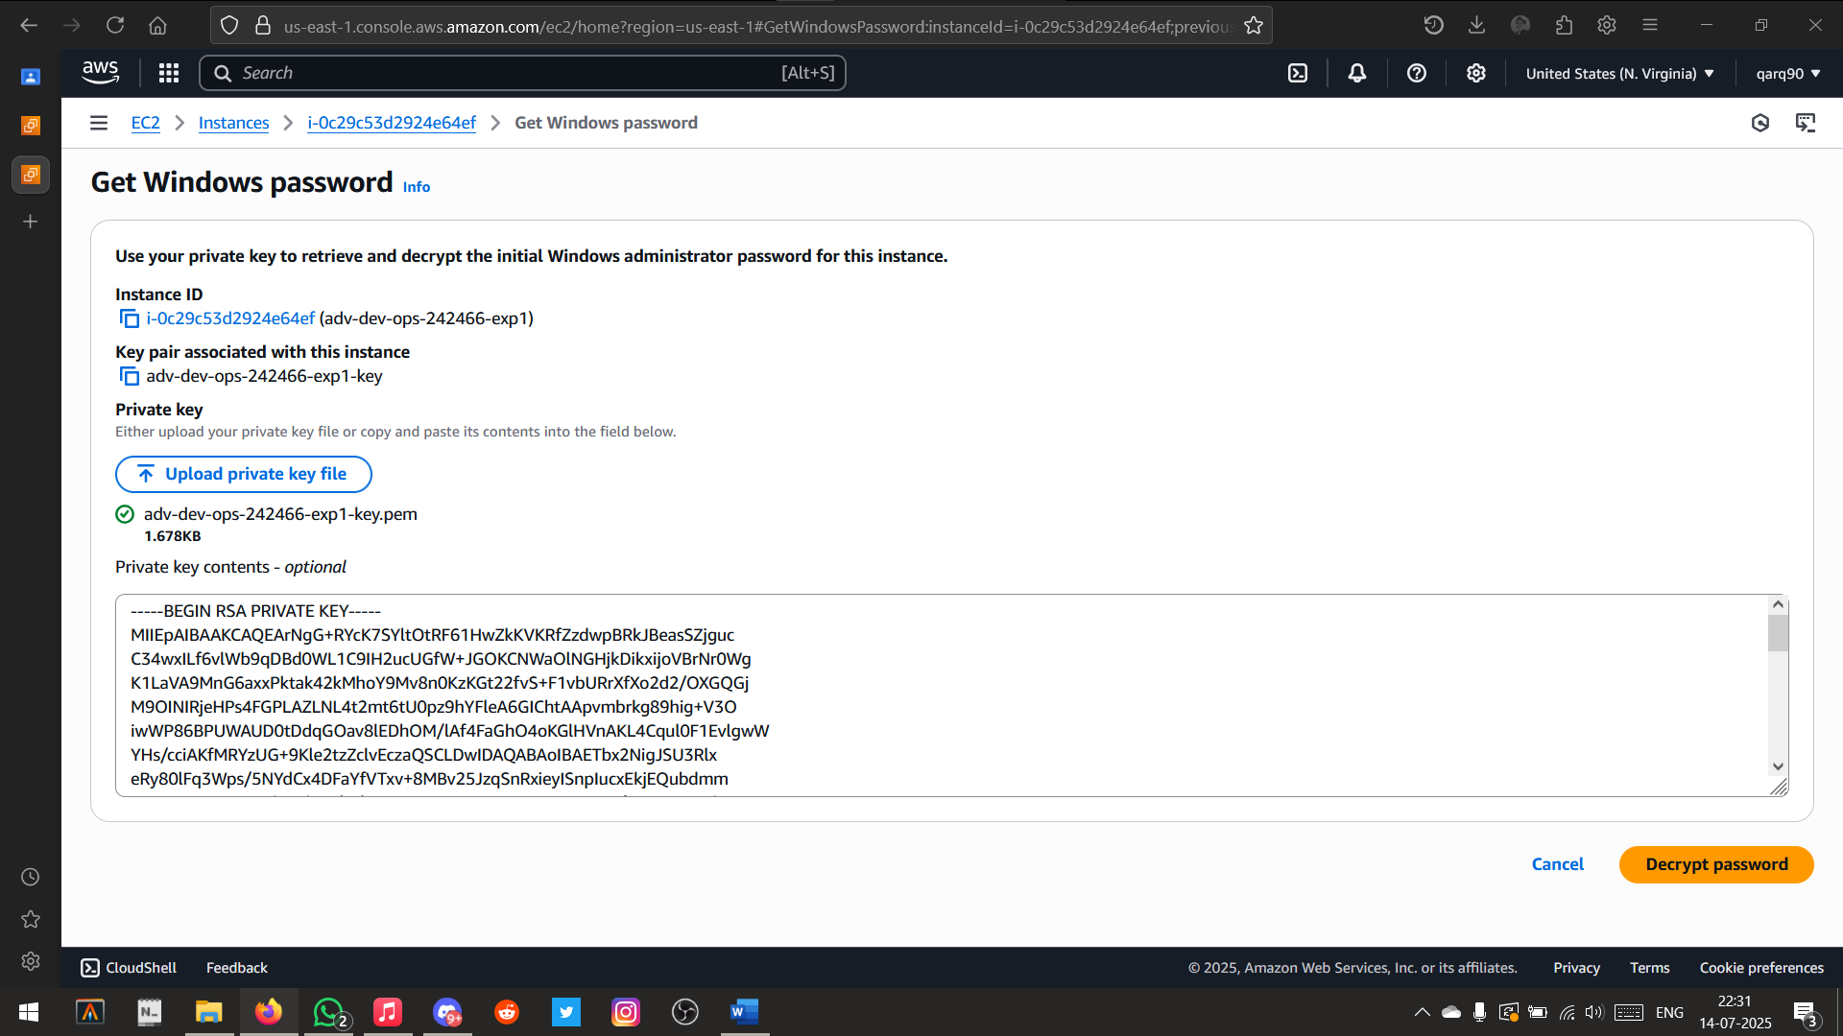

Decrypting the .pem file to get the password

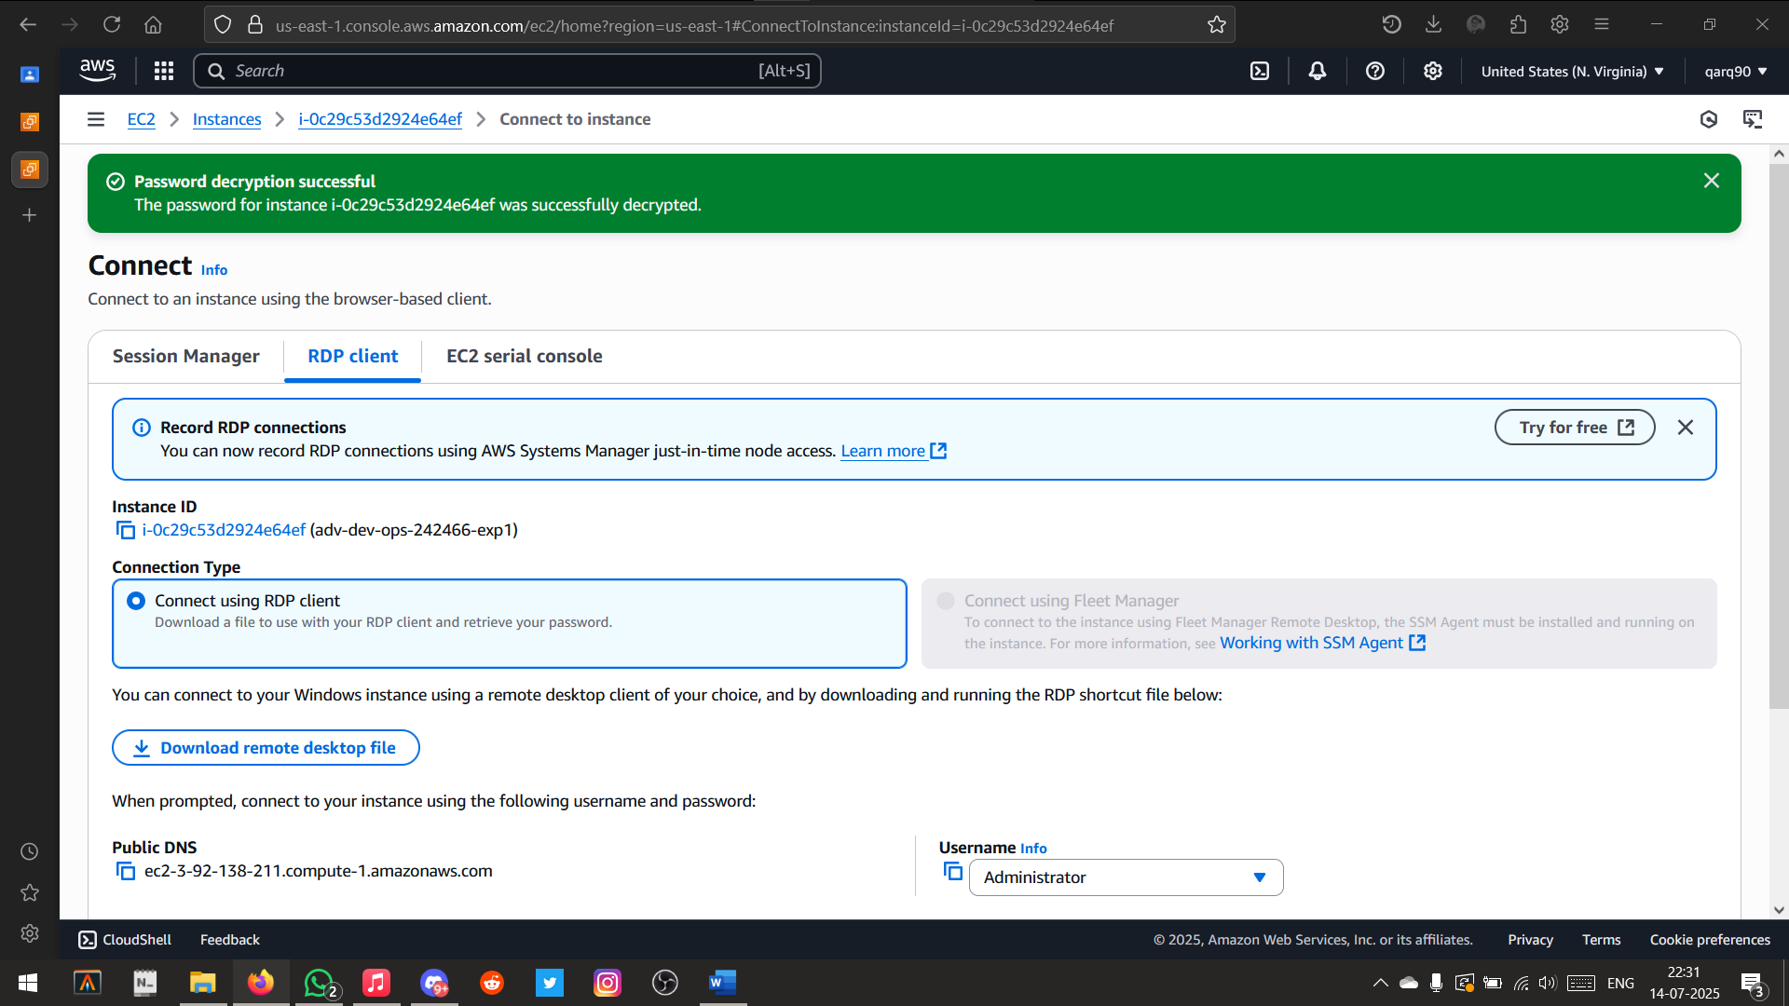

Password Decrypted Successfully

Password:

.bZru96.X2z7pH!*R%8P.!a7(&eZ@-WU

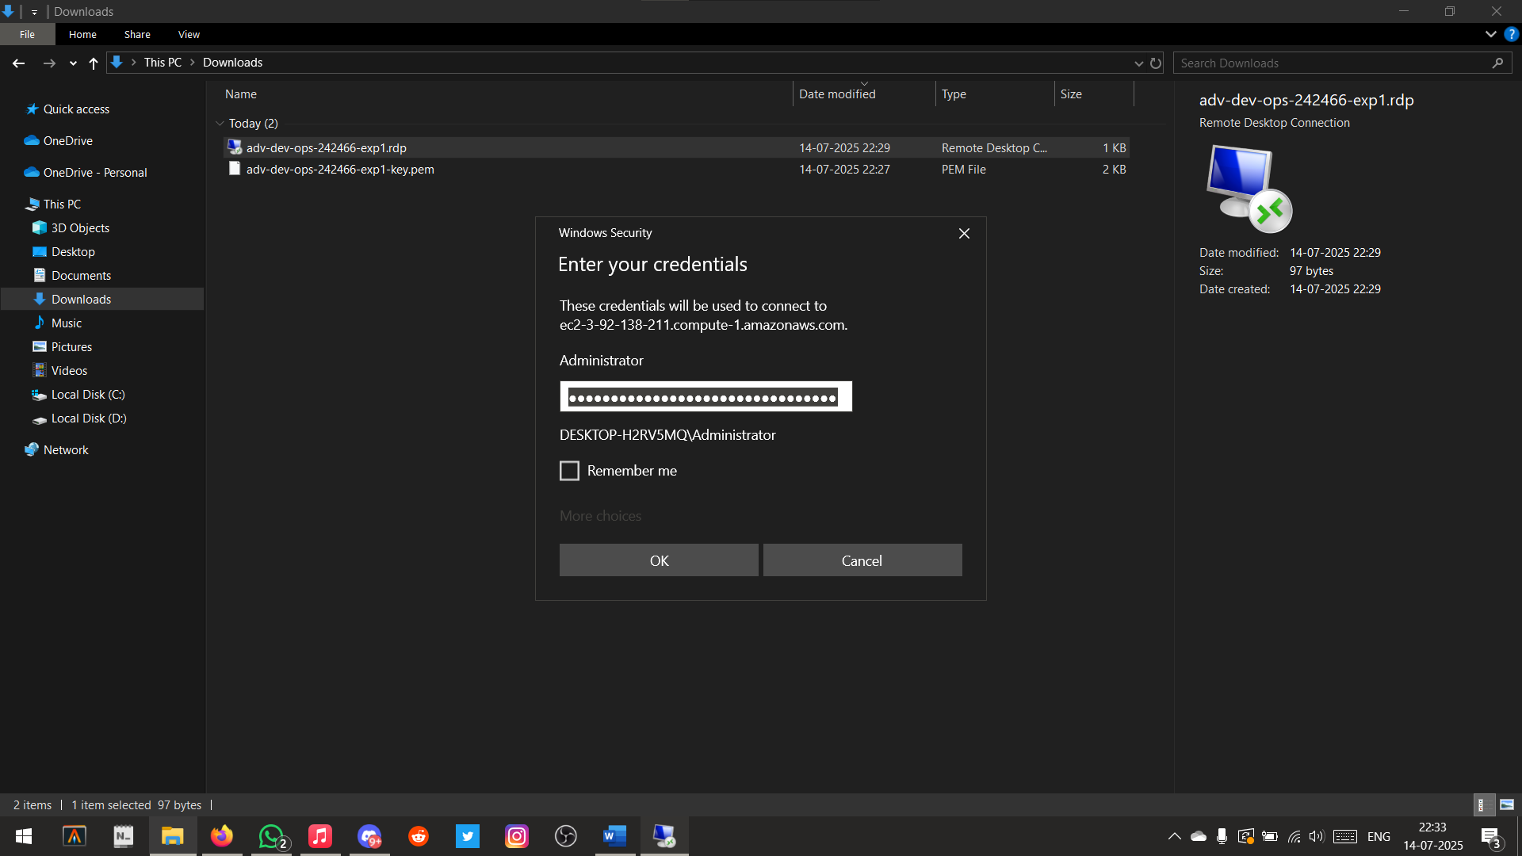

Entering the password in RDP Client

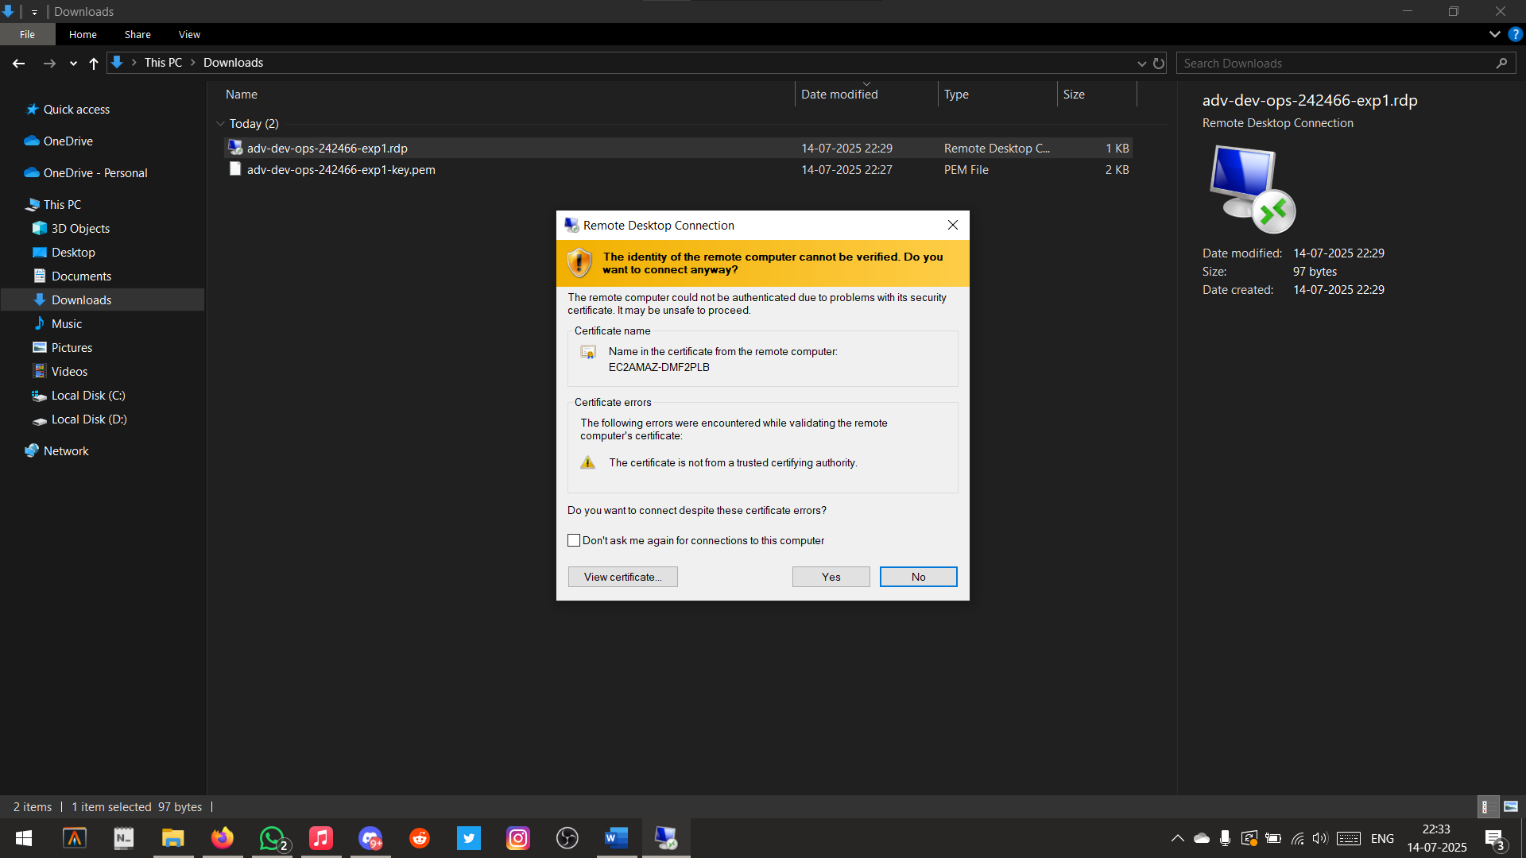

Accepting Permissions

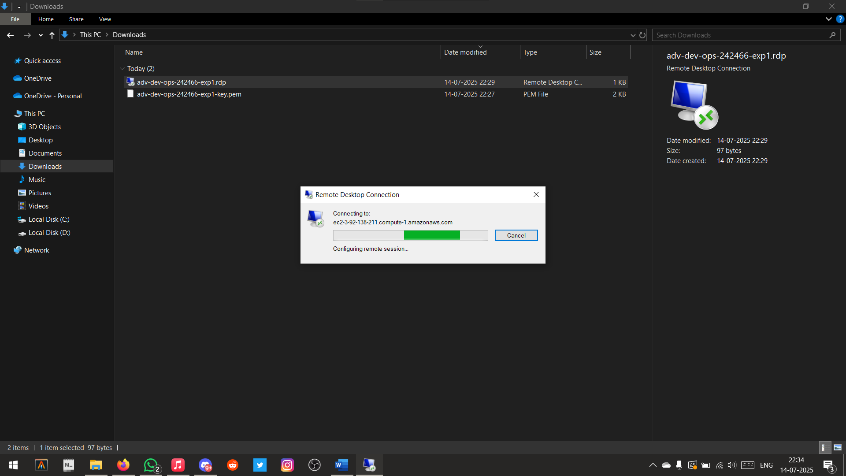

Connecting to the EC2 Instance

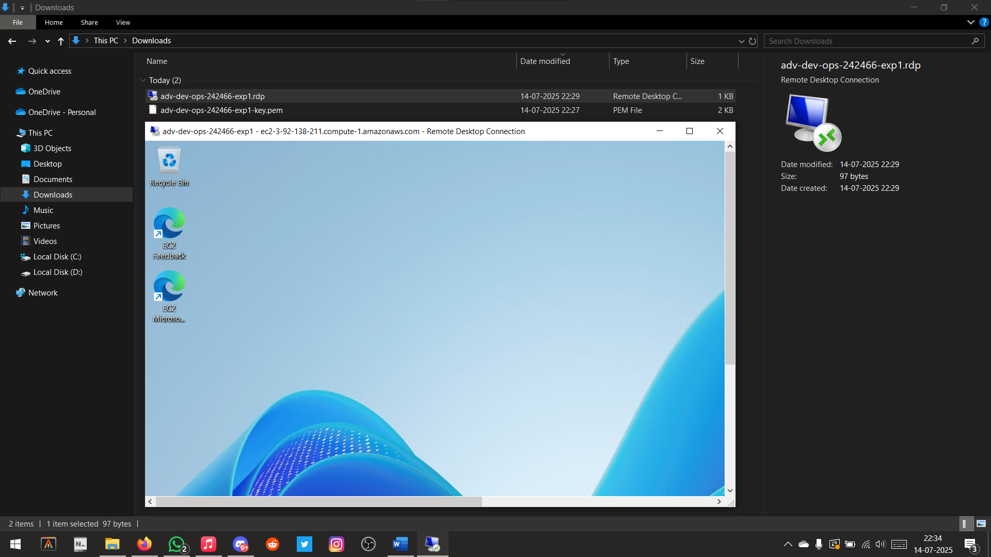

Instance Launched Successfully

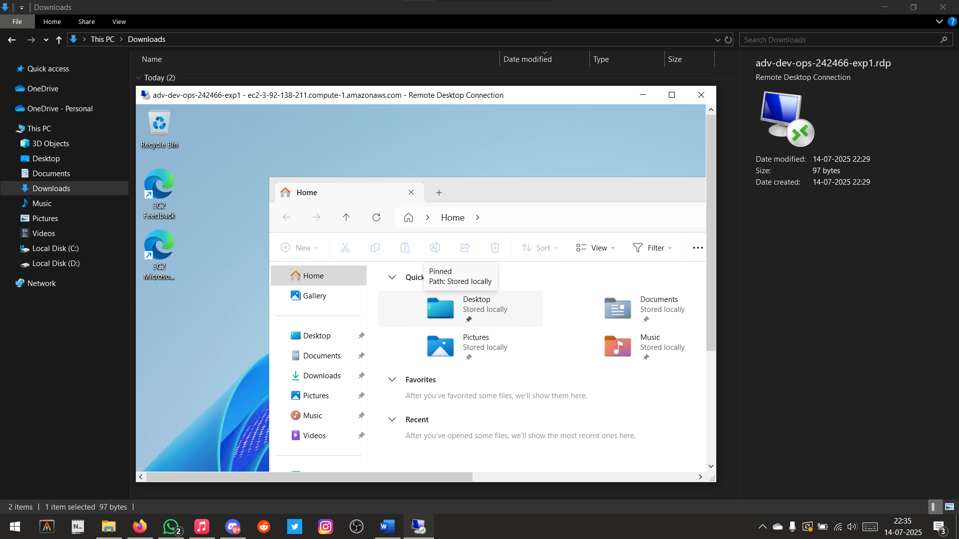

Opened File Explorer on EC2 Instance

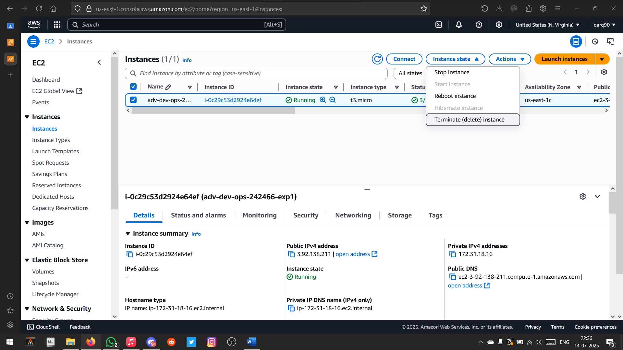

Terminating the Instance

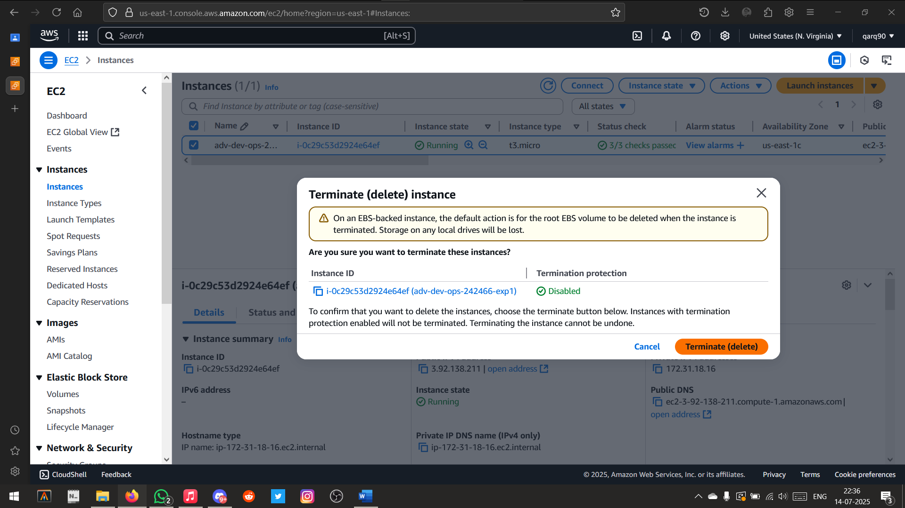

Deleting the EC2 Instance

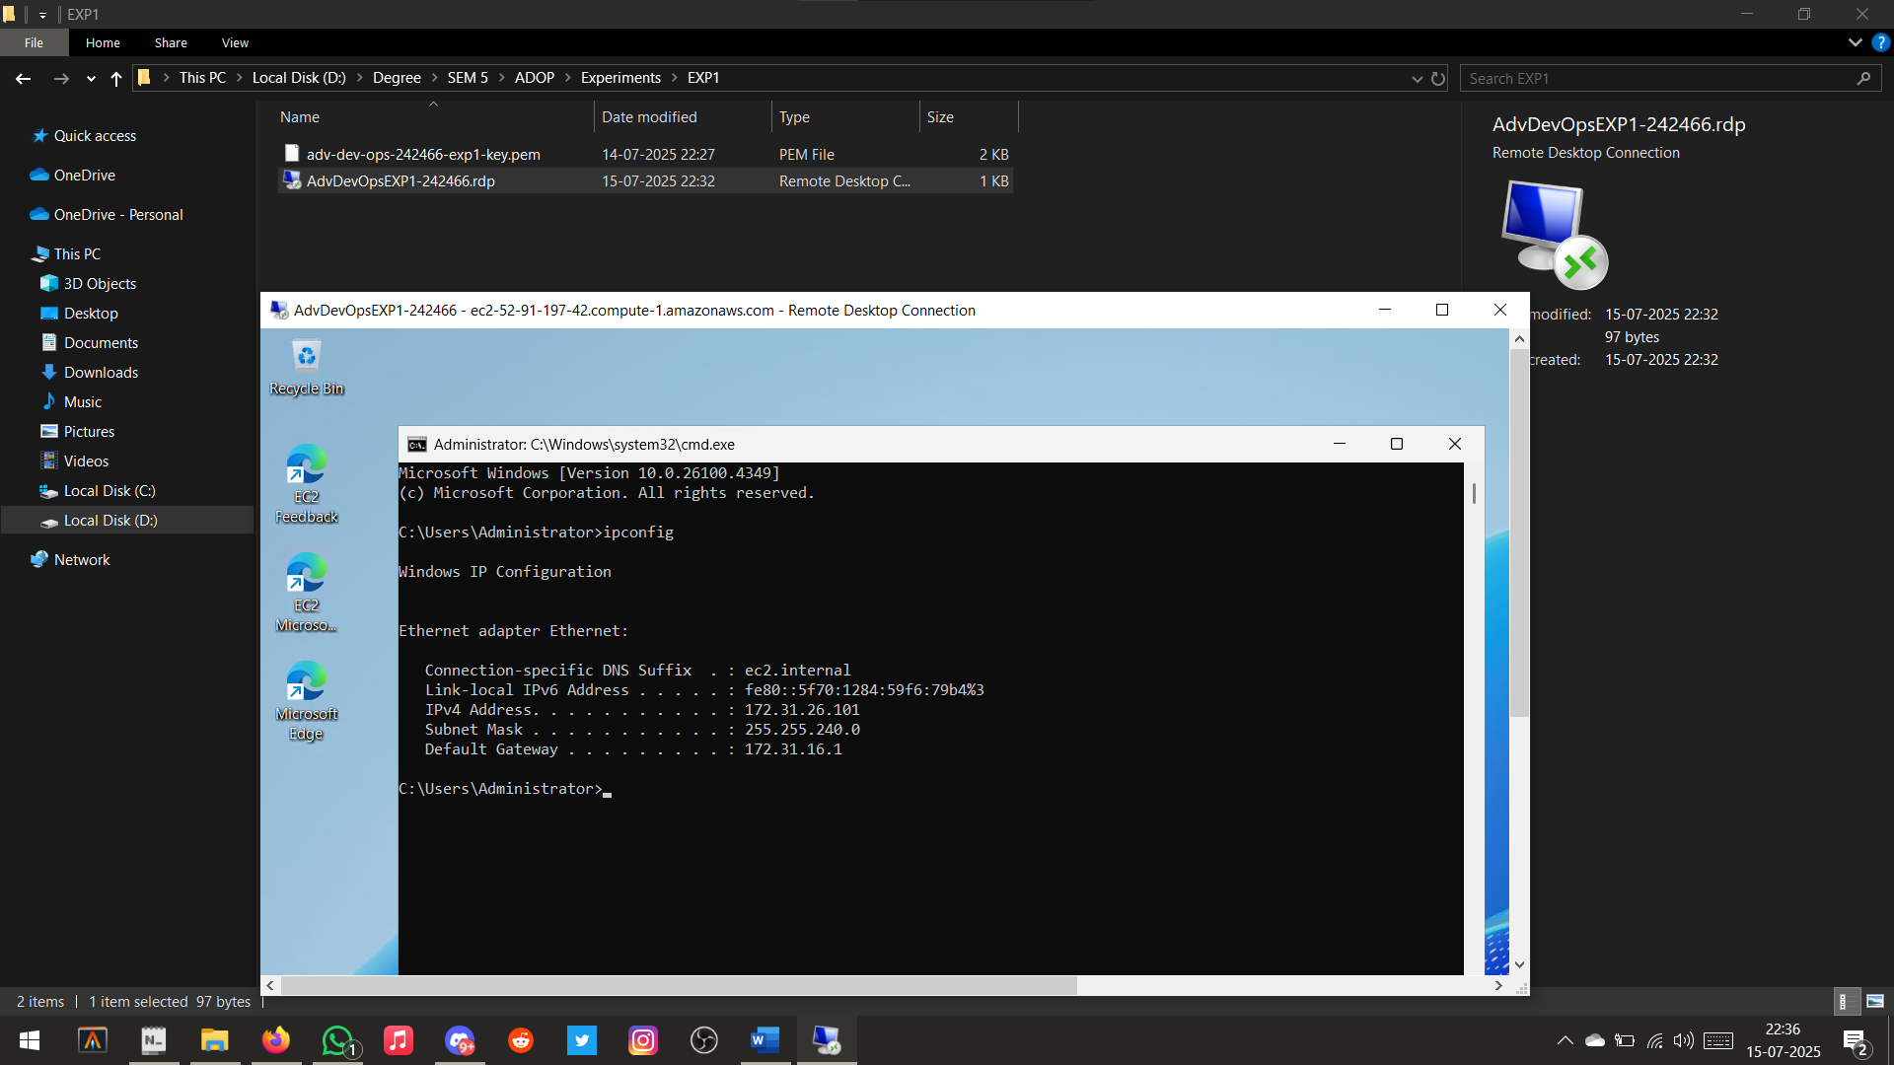

Checking IP address